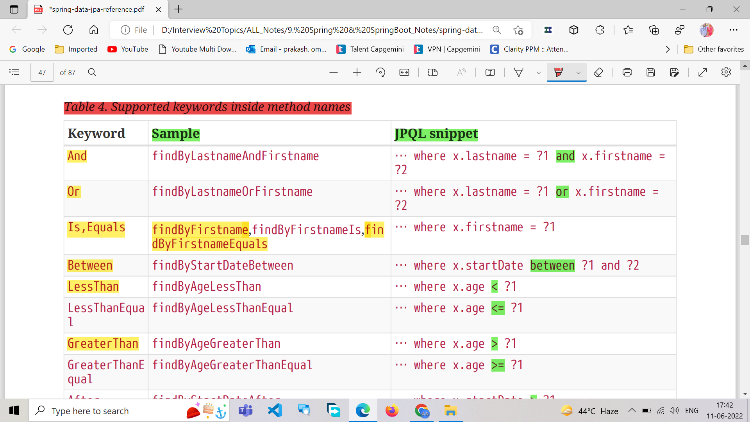

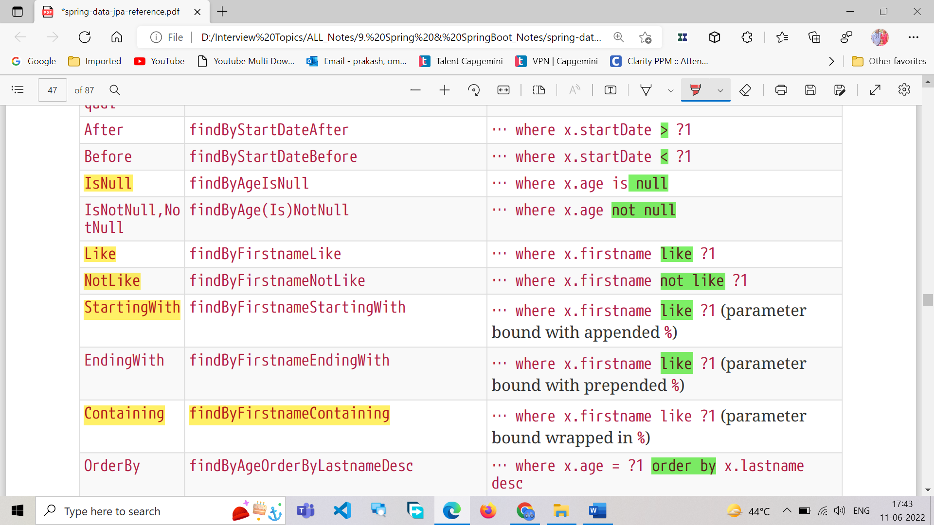
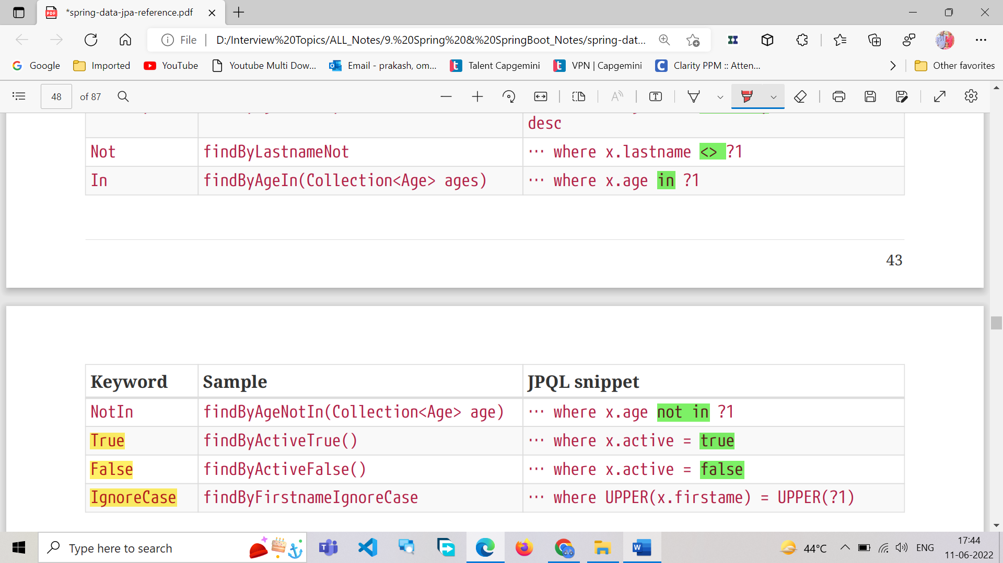

Default available methods
CrudRepository and PagingAndSortingRepository offer default methods such as: findAll, findAllById, findById, deleteAll, deleteById, save, saveAll.
- <S extends T> save(S entity) – Used to save a single entity at a time.
- Iterable<S> saveAll(Iterable<S> entities) – we can save multiple entities at a time.
- boolean existsById(ID id) – used to check whether an entity is already exited in DB for given Id.
- Optional<T> findById(ID id) – use to get entity basis of id.
- Iterable<T> findAll() – find all entity of paricular type.
- Iterable<T> findAllById(Iterable<ID> ids) – return all entity of given ids.
- long count() – returns the number of entities
- void deleteById(ID id) – delete the entity on basis of id
- void delete(T entity) – delete the entity which one we are passing.
- void delete(Iterable<? extends T> entities) – delete multiple entities which we are passing.
- void deleteAll() – delete all entities.

TESTING (JUNIT)

Spring Data JPA findBy Column Name with Example
@Entity
@Table(name = "employees")
public class Employee {
@Id
@GeneratedValue(strategy = GenerationType.IDENTITY)
private long id;
@Column(name = "first_name", nullable = false)
private String firstName;
@Column(name = "last_name", nullable = false)
private String lastName;
@Column(nullable = false)
private String email;
}
@RestController
@RequestMapping("/api/employees")
public class EmployeeController {
private EmployeeService employeeService;
public EmployeeController(EmployeeService employeeService) {
this.employeeService = employeeService;
}
@GetMapping("{id}")
public ResponseEntity<Employee> getEmployeeById(@PathVariable("id") long employeeId){
return employeeService.getEmployeeById(employeeId)
.map(ResponseEntity::ok)
.orElseGet(() -> ResponseEntity.notFound().build());
}
public interface EmployeeService {
Employee saveEmployee(Employee employee);
List<Employee> getAllEmployees();
Optional<Employee> getEmployeeById(long id);
Employee updateEmployee(Employee updatedEmployee);
void deleteEmployee(long id);
}
@Service
public class EmployeeServiceImpl implements EmployeeService {
private EmployeeRepository employeeRepository;
public EmployeeServiceImpl(EmployeeRepository employeeRepository) {
this.employeeRepository = employeeRepository;
}
@Override
public Optional<Employee> getEmployeeById(long id) {
return employeeRepository.findById(id);
}
public interface EmployeeRepository extends JpaRepository<Employee, Long> {
Optional<Employee> findByEmail(String email);
}

REPOSITORY LAYER TEST
---------------------------------
@DataJpaTest
public class EmployeeRespositoryTests {
@Autowired
private EmployeeRepository employeeRepository;
//OM PRAKASH
private Employee employee;
@BeforeEach
public void setup()
{
employee = Employee.builder()
.firstName("Om")
.lastName("Prakash")
.email("om.prakash@gmail,com")
.build();
}

// JUnit test for get employee by id operation
@DisplayName("JUnit test for get employee by id operation")
@Test
public void givenEmployeeObject_whenFindById_thenReturnEmployeeObject(){
// given - precondition or setup
/* Employee employee = Employee.builder()
.firstName("Ramesh")
.lastName("Ramesh")
.email("ramesh@gmail,com")
.build();
*/
employeeRepository.save(employee);
// when - action or the behaviour that we are going test
Employee employeeDB = employeeRepository.findById(employee.getId()).get();
// then - verify the output
assertThat(employeeDB).isNotNull();
}
SERVICE LAYER TEST
---------------------------------
@ExtendWith(MockitoExtension.class)
public class EmployeeServiceTests {
@Mock
private EmployeeRepository employeeRepository;
@InjectMocks
private EmployeeServiceImpl employeeService;
private Employee employee;

// JUnit test for getEmployeeById method
@DisplayName("JUnit test for getEmployeeById method")
@Test
public void givenEmployeeId_whenGetEmployeeById_thenReturnEmployeeObject(){
// given
given(employeeRepository.findById(1L)).willReturn(Optional.of(employee));
// when
Employee savedEmployee = employeeService.getEmployeeById(employee.getId()).get();
// then
assertThat(savedEmployee).isNotNull();
}

CONTROLLER LAYER TEST
---------------------
@WebMvcTest
public class EmployeeControllerTests {
@Autowired
private MockMvc mockMvc;
@MockBean
private EmployeeService employeeService;
@Autowired
private ObjectMapper objectMapper;

// positive scenario - valid employee id
// JUnit test for GET employee by id REST API

@Test
public void givenEmployeeId_whenGetEmployeeById_thenReturnEmployeeObject() throws Exception{
// given - precondition or setup
long employeeId = 1L;
Employee employee = Employee.builder()
.firstName("Ramesh")
.lastName("Fadatare")
.email("ramesh@gmail.com")
.build();
given(employeeService.getEmployeeById(employeeId)).willReturn(Optional.of(employee));
// when - action or the behaviour that we are going test
ResultActions response = mockMvc.perform(get("/api/employees/{id}", employeeId));
// then - verify the output
response.andExpect(status().isOk())
.andDo(print())
.andExpect(jsonPath("$.firstName", is(employee.getFirstName())))
.andExpect(jsonPath("$.lastName", is(employee.getLastName())))
.andExpect(jsonPath("$.email", is(employee.getEmail())));
}
// negative scenario - valid employee id
// JUnit test for GET employee by id REST API
@Test
public void givenInvalidEmployeeId_whenGetEmployeeById_thenReturnEmpty() throws Exception{
// given - precondition or setup
long employeeId = 1L;
Employee employee = Employee.builder()
.firstName("Ramesh")
.lastName("Fadatare")
.email("ramesh@gmail.com")
.build();
given(employeeService.getEmployeeById(employeeId)).willReturn(Optional.empty());
// when - action or the behaviour that we are going test
ResultActions response = mockMvc.perform(get("/api/employees/{id}", employeeId));
// then - verify the output
response.andExpect(status().isNotFound())
.andDo(print());
}

DEPENDENCIES REQUIRED
Application.property file add below lines

###############MYSQL8####################
#spring.datasource.url=jdbc:mysql://localhost:3306/ems?useSSL=false
#spring.datasource.username=root
#spring.datasource.password=root
#spring.jpa.properties.hibernate.dialect=org.hibernate.dialect.MySQL5InnoDBDialect
#spring.jpa.show-sql=true
#spring.jpa.hibernate.ddl-auto=update
# default path: h2-console
###############DB2####################
spring.h2.console.enabled=true
spring.h2.console.path=/h2-ui
spring.datasource.url=jdbc:h2:mem:testdb
spring.datasource.driverClassName=org.h2.Driver
spring.datasource.username=sa
spring.datasource.password=
spring.jpa.properties.hibernate.dialect=org.hibernate.dialect.H2Dialect
spring.jpa.show-sql=true
spring.jpa.hibernate.ddl-auto= update
server.port=2022

-----------------------------------------
<dependency>
<groupId>org.springframework.boot</groupId>
<artifactId>spring-boot-starter-data-jpa</artifactId>
</dependency>

<dependency>
<groupId>com.h2database</groupId>
<artifactId>h2</artifactId>
</dependency>

URL:- http://localhost:2022/h2-ui

